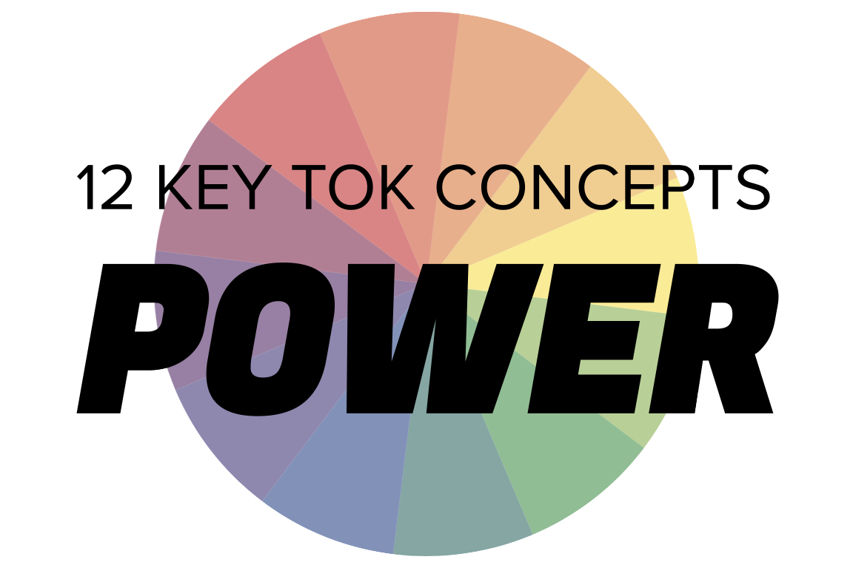 | POWER

Understanding the 12 key concepts
- The 12 key concepts are ones that have been identified as having a particular significant relationship to knowledge.
- Understanding, exploring, and using these concepts will help you to understand the way knowledge is produced and used, within the core and optional themes, and the areas of knowledge.
- You should also try to use the key concepts as extensively as possible in the two TOK assessment tasks.
Starting points for power  - How many online definitions can you find for ‘power’?  - Which one do you think best sums up this concept, and why?  - Which of the quotes below do you think provides us with the best insight into power? Are there any you disagree with?  - How might the possession of power change the way we understand the world? | Quotes on power  - All things are subject to interpretation whichever interpretation prevails at a given time is a function of power and not truth. Friedrich Nietzsche  - Truth is powerful and it prevails. Sojourner Truth  - Knowledge is power. Francis Bacon  - The power to question is the basis of all human progress. Indira Gandhi  - The power of imagination makes us infinite. John Muir  - A word after a word after a word is power. Margaret Atwood
Interlinking the key concepts  - Does power undermine our ability to be objective about the world?  - How much power does evidence provide us with when we make knowledge claims?  - Which plays more of a role in the way we produce knowledge - our values, or power?  - Can power obstruct the way knowledge is justified?  - Do those with power have responsibilities to ensure knowledge is used responsibly? | Relating power to the TOK course  - How does power affect the way knowledge is produced within the areas of knowledge?  - In what ways can language be used to consolidate power as ideas are communicated?  - How does political and religious power influence the way we understand the world?  - Do egalitarian power structures within indigenous societies affect the way knowledge is produced?
Relating power to the TOK exhibition  - IAP-3: Think about whether power affects the reliability of knowledge  - IAP-7: Think about the relationship between power and the possession (or non-possession) of knowledge  - IAP-17: Think about whether the motive for seeking knowledge is related to the acquisition or consolidation of power  - IAP-29: Think about how power can lead to the ‘ownership’ of knowledge | Relating power to the Big Questions  - BQ1 - What relationship does power have with the production of knowledge?  - BQ2 - Does power always adversely affect our ability to understand?  - BQ3 - How is knowledge communicated in order to protect power?  - BQ4 - Do powerful perspectives always overwhelm weaker ones when it comes to understanding?  - BQ5 - How has knowledge been affected by the development of power over time?  - BQ6 - How do expert knowers discern the effect of power on our ability to understand?

Real-world contexts for power
The media sources below explicitly mention power, and discuss this key concept in a real-world context. Use the find command (ie Command/Control+F) to locate the term in the article or transcript of the video, and you’ll see where it features. Check back regularly, as we update these media sources every month.
Big Question / knowledge framework | Description of media source and story and links to the course
BQ1 / Nature & scope | A Conversation article, looking at what constitutes a ‘miracle’ for the Catholic Church. Religion, Knowledge & the knower, Language, Natural sciences  An Aeon essay, which explores “what makes something worth believing”. Knowledge & the knower, Human sciences  A Guardian article, asking the question, ‘Can history teach us anything about the future of war and peace?’ History, Politics, Human sciences  An Aeon video, looking at how significant historical footage is ‘locked’ behind paywalls, meaning ordinary knowers are unable to draw on it when they study the past. History, Technology  A Wired article, looking at how a board game designer may be able to help us to understand and engage with the climate crisis. Natural sciences, knowledge & the knower  A Guardian article, looking at how the absence of touching those we love during lock-down has revealed the importance of this sense. Knowledge & the knower  This DW video looks at how conspiracy theories develop - and how the present situation exacerbates this tendency. Knowledge & the knower, Natural sciences, Human sciences  A Guardian article, considering how the pandemic is affecting our susceptibility to rumour and superstition, and whether ‘evidence-based’ belief is making a come-back. Natural sciences, human science, technology, language
BQ2 / Values | A Project Syndicate article by Peter Singer, analysing Elon Musk’s claims to be a ‘free speech absolutist’. Technology, Human sciences, Politics  A Guardian article, looking at the work of environmental artist Agnes Denes, who planted a field of wheat in Battery Park, Manhattan. The arts, Natural sciences, Human sciences  A Vox article, which attempts to understand US public opinion towards abortion rights via quantitative and qualitative information. Human sciences, Politics, Religion  A Guardian opinion piece, in which the writer Michael Harriot asserts the legacy of MLK has been appropriated by groups who oppose what he stood for. History, Religion  A Guardian article, written by Mary Beard, who argues that public statues “have an important job to do in helping us face up to the past.” History, The arts, Language  A Widewalls article, presenting a range of artworks that help us to remember and commemorate the events of November 11th, 2001. The arts, History, Knowledge & the knower  A nice BBC video that explores the prevalence of metaphors in the way we use language. Language, knowledge & the knower, politics, human sciences  A New Humanist article, which considers the importance of remembering historical injustices, as a way of guarding against the misuse of power in the present. History, human sciences, politics
BQ3 / Methods, tools, and practices | A Guardian article looking at how politicians and business leaders communicate their power and agenda by the clothes they wear. Language, Politics, Human sciences  A Smithsonian article, looking at a 1945 Holocaust comic that tried to communicate the horrors of the Nazi death camps. Language, History, The arts, Knowledge & the knower  A Conversation article, looking at how punctuation has been adapted as a central tool of Black activism. Language, human sciences, politics  A Washington Post article, looking at how the founding generation of the United States - like the leaders of any other nation - rewrote the past to consolidate their position in the present. History, politics
BQ4 / Perspectives | A Guardian article, exploring the way The Onion’s satire has developed over the past few years, and what this tells us about society. Politics, The arts, Knowledge & the knower, Human sciences  A BBC article, considering whether Bolivia’s high proportion of female lawmakers can inspire political change elsewhere in the world. Politics, Human sciences, Knowledge & the knower  A Salon article, arguing that the term ‘feminist science’ is not an oxymoron, and offers a powerful set of tools for examining knowledge. Natural sciences, Knowledge & the knower, Politics  A New Humanist article, considering the shockingly high rate of violence against perceived witches, and the thinking behind this phenomenon. Indigenous societies, Religion, Knowledge & the knower, Human sciences  An Aeon essay, looking at six different narratives of the nature and effect of globalization. Human sciences, History, Politics, Technology  A History Today photo essay that looks at what happens when our documentary evidence of indigenous culture is not based on ‘asymmetric power relations, subjugation, and colonialism’. Indigenous societies, history  A New Republic article which discusses the problems with the way people seem to be getting more and more politically polarized. Politics, language, human sciences  This New Statesman article explores how landscape (specifically, woodland) impacts on the events of the past in as significant a way as ‘king, battle, or war’. History, natural sciences
BQ5 / Methods, tools, and practices | A New Humanist article, considering whether psychology is “the superstition of our age”. Human sciences, Knowledge & the knower, Religion  A Big Think video, in which Jimena Canales discusses the phenomenon of ‘science demons’ - manifestations of doubt and uncertainty that existed for certain thinkers. Natural sciences, Human sciences, Language, Knowledge & the knower, Religion, Technology  An FT article by Yuval Noah Harari, in which he discusses what we can learn about the world from our collective response to the Covid crisis. Human sciences, Natural sciences, history, politics, technology  An Art Newspaper article, looking at how a work of art by Banksy has been burned, and turned into an ‘NFT’. The arts, technology  A New Humanist article, which considers the ‘miracle of the plague year’ - 1665 - during which Isaac Newton created his law of universal gravitation. Natural sciences, knowledge & the knower
BQ6 / Methods, tools, and practices | A Vox podcast and interview with Neil deGrasse Tyson, in which he discusses how many people are unable to distinguish between fact and opinion. Knowledge & the knower, Natural sciences, Human sciences, anything, really!  A BBC article, discussing how to debate with those who reject conventional scientific thinking. Knowledge & the knower, Natural sciences  A Big Think article, exploring the line between ‘healthy skepticism’ and ‘toxic denialism’. Knowledge & the knower, most AOKs & themes  A Guardian article, arguing that indigenous peoples were shut out of the Cop26 discussions - “literally and figuratively”. Indigenous societies, Natural sciences, Politics, Human sciences  A Guardian article, which considers whether you need to speak a country’s language in order to fully understand its politics, culture, and history. Language, politics, human sciences, history  A Guardian conversation between John Banville and John Le Carré, reprinted on the day of the latter’s death. The arts, politics, language, history

